|  |  |  |  |  |  |  |  |
| --- | --- | --- | --- | --- | --- | --- | --- |
| *Assignment 2* |  |  |  |  |  |  |  |
|  |  |  |  |  |  |  |  |
| Problems from the text book | | |  |  |  |  |  |
|  |  |  |  |  |  |  |  |
| *1) For each function f(n) and time t in the following table, determine the largest size n of a problem that can be solved in time t,* | | | | | | | |
| *assuming that the algorithm to solve the problem takes f(n) microseconds.* | | | | |  |  |  |

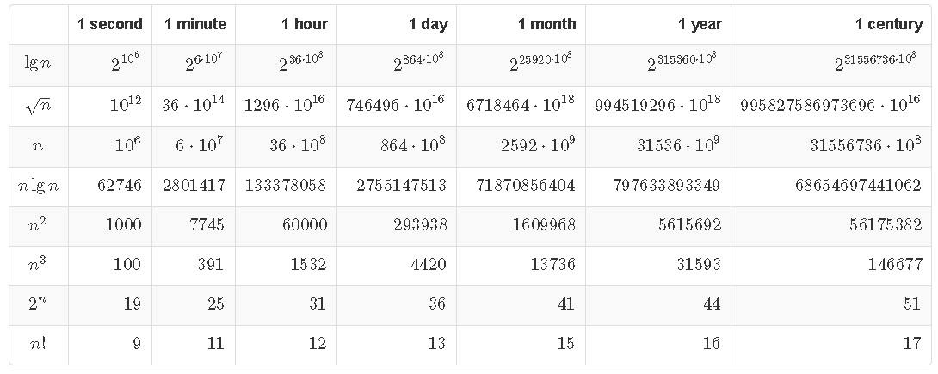

|  |  |  |  |  |  |  |  |
| --- | --- | --- | --- | --- | --- | --- | --- |
| 2) Calculate the polynomial time for the Bubble Sort. Use a different constant for each operation. | | | | | | | |
|  |  |  |  |  |  |  |  |
| BUBBLESORT(A) | |  |  |  |  |  |  |
| 1 for i = 1 to A.length - 1 | |  |  |  |  |  |  |
| 2 for j = Lengthen downto i + 1 | | |  |  |  |  |  |
| 3 if A[j] < A[j - 1] | |  |  |  |  |  |  |
| 4 exchange A[j] with A[j - 1] | | |  |  |  |  |  |
|  |  |  |  |  |  |  |  |
|  |  |  |  |  |  |  |  |
|  |  |  |  |  |  |  |  |
| 3) Show that When |x| ≤ 1, we have the approximation | | | | |  |  |  |
|  |  |  |  |  |  |  |  |
|  | *e^x = 1 + x + Θ(x^2).* | |  |  |  |  |  |